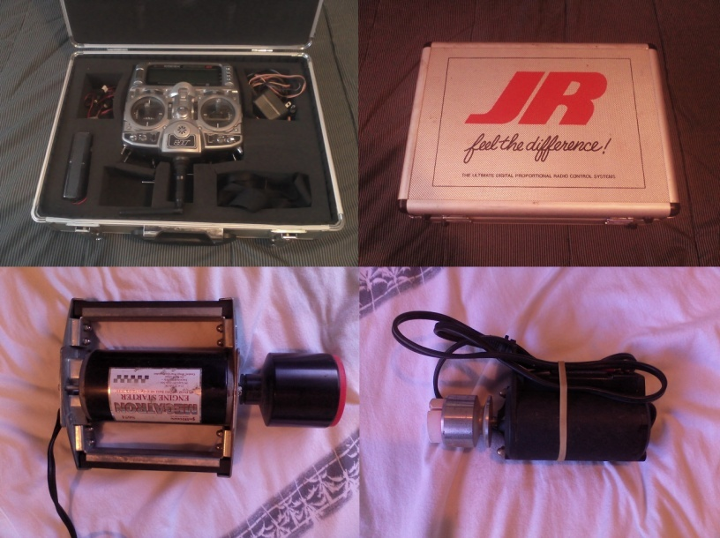

**RC Equipment $3000.00**

To Much To List Special Deal Over $4500.00 Value  
  
JR X9303 2.4 receiver with 7 different planes all with JR receivers ready to fly + batteries, chargers   
starters, stands and many extra parts  
  
Ultra Stick Lite2, 2 set of wing, 2 Zenoah (G26A 2.4hp-G20ei-1.7hp) 1 Sata (FA-82 1.5hp) gas engines

Megatron Engine starter Sullivan S651  
  
Cap 232 BP E-Flight 890Kv Brushless  
  
Twist 3D 480 E-Flight 1020Kv Brushless   
  
Fun Jet  
  
Striker E-Flight 1020Kv Brushless   
  
Super Cub  
  
F-15 Eagle still in box with some retracts

